Major：[Name of Major ]

Name：[Student Name]

Thesis Advisor：[Type the thesis advisor's name]

Due Date：[Type the due date]

[Turing Machine ]

# 1.0 Introduction

Welcome to this comprehensive overview of the Turing Machine, a foundational concept in the field of computer science. In this document, we will explore the purpose, operation, and significance of the Turing Machine, along with its various components and use cases.

## 1.1 Purpose

The Turing Machine serves as a theoretical construct designed to help us understand the fundamental principles of computation and computational processes. It was introduced by Alan Turing in the 1930s as a thought experiment to explore the limits of what can be computed.

At its core, the Turing Machine embodies a simple yet profound idea: any computation that can be carried out by a digital computer can also be executed by a Turing Machine. This insight forms the basis for the theory of computability, which is concerned with identifying what tasks are algorithmically solvable and what tasks are beyond the reach of computation.

## 1.2 The Turing Machine

The Turing Machine is not a physical machine but rather a mathematical abstraction. It consists of a few essential components that, when combined, encapsulate the key principles of computation. These components include:

- Tape: An infinitely long tape divided into discrete cells, each capable of holding a symbol from a finite alphabet. The tape serves as the memory of the machine.

- Read/Write Head: A mechanism that can read the symbol currently under the head and write a new symbol onto the tape. The head can move left or right along the tape.

- States: A finite set of states that the machine can be in at any given moment. The behavior of the machine is determined by its current state and the symbol it reads.

- Transition Rules: A set of rules that dictate how the machine should transition from one state to another based on the symbol it reads. Each rule specifies the new symbol to write, the direction to move the head (left or right), and the next state to enter.

The simplicity of the Turing Machine model belies its significance. By abstracting away the complexities of hardware and focusing solely on the mechanics of computation, Turing Machines allow us to explore the theoretical limits of what can and cannot be computed. This exploration has profound implications for fields ranging from theoretical computer science to algorithm design, as well as philosophy and the foundations of mathematics.

The rest of this document will delve into the operation of the Turing Machine, its use cases, its representation through UML diagrams, its implementation details, variations, applications, significance, potential enhancements, and testing strategies. Through this comprehensive exploration, we aim to provide you with a clear understanding of the Turing Machine's role in shaping the field of computer science and its ongoing influence on modern technology and thought.

# 2.0 Process Model

Before we delve into the intricacies of the Turing Machine, let's establish a basic process model to guide our exploration:

1. Initialization: The Turing Machine starts in a specific initial state with the read/write head positioned over the tape.

At the beginning of a computation, the Turing Machine is initialized to a certain state, often referred to as the "start state." The read/write head is placed at a particular cell on the tape, ready to begin reading and writing symbols.

2. Reading and Writing: The read/write head reads the symbol on the current tape cell and writes a new symbol based on the transition rules.

As the machine operates, it reads the symbol currently under the read/write head. Based on the current state and the read symbol, the machine determines the appropriate transition rule to apply. This rule specifies the new symbol to write onto the tape in place of the read symbol.

3. Moving the Tape: The read/write head moves left or right on the tape as specified by the transition rules.

After writing the new symbol, the read/write head is instructed to move either one cell to the left or one cell to the right. This movement allows the machine to access different portions of the tape and continue the computation.

4. Transition Rules: The Turing Machine follows a set of transition rules that dictate its behavior based on the current state and symbol.

Transition rules define how the machine's state and tape content should change in response to the current state and symbol. Each rule corresponds to a specific combination of state and symbol and specifies the new state, new symbol, and head movement direction.

5. Halting: The machine halts when it enters a specified halting state, indicating the completion of the computation.

The computation is considered complete when the Turing Machine enters a designated halting state. This state signifies that the machine has finished its task or reached a point where further computation is unnecessary. Once the machine enters the halting state, it ceases its operation.

By breaking down the operation of the Turing Machine into these key steps, we create a structured framework for understanding its behavior. This process model forms the basis for analyzing specific use cases, creating UML diagrams to visualize its behavior, understanding its theoretical underpinnings, and exploring its broader applications. In the following sections, we will dive deeper into the various aspects of the Turing Machine to gain a comprehensive understanding of its significance in the field of computer science.

# 3.0 Overview of the Turing Machine

## 3.1 Basic Concepts

To better understand the Turing Machine, let's delve deeper into its basic concepts:

- Alphabet: The alphabet of a Turing Machine refers to the set of symbols that the machine can read from and write onto the tape. These symbols can include numbers, letters, or any other characters that the machine can manipulate. The alphabet provides the building blocks for the tape's content.

- States: The Turing Machine operates in a finite set of states. Each state represents a specific configuration or condition of the machine during its computation. The machine can transition from one state to another based on the transition rules.

- Transition Rules: Transition rules define the behavior of the Turing Machine. They specify how the machine should transition from one state to another, depending on the symbol it reads from the tape. Transition rules encompass three main components: the current state, the read symbol, and the instructions for updating the tape (writing a new symbol), moving the head (left or right), and transitioning to a new state.

## 3.2 Components of the Turing Machine

The Turing Machine comprises several essential components that interact to carry out computations:

- Tape: The tape is a vital part of the Turing Machine's memory. It consists of an infinite sequence of cells, each of which can hold a symbol from the alphabet. The tape provides the workspace where the machine reads and writes symbols during its computation.

- Read/Write Head: The read/write head is a pivotal component that interacts with the tape. It can move left or right along the tape and reads the symbol on the current cell. Additionally, the head can write new symbols onto the tape, effectively altering the content.

- Transition Function: The transition function defines the machine's behavior. It maps combinations of the current state and read symbol to instructions for updating the tape, moving the head, and transitioning to a new state. The transition function encapsulates the core logic of the Turing Machine's computation.

## 3.3 Operation of the Turing Machine

The Turing Machine operates through a sequence of steps that follow the transition rules:

1. Initialization: The machine starts in an initial state with the read/write head positioned over a specific cell on the tape. The tape contains the input data for the computation.

2. Reading and Writing: The read/write head reads the symbol on the current tape cell. Based on the current state and the read symbol, the machine refers to the transition rules to determine the next steps.

3. Transition Rule Application: The machine identifies the appropriate transition rule by matching the current state and the read symbol to the rule's conditions. Once a match is found, the machine follows the instructions in the rule.

4. Updating the Tape: The machine writes a new symbol onto the current tape cell, replacing the original symbol. This step reflects the computational operation being performed.

5. Moving the Tape Head: Based on the transition rule, the read/write head moves left or right along the tape to position itself over the next cell.

6. Transition to New State: The machine transitions to a new state as defined by the transition rule. This state change prepares the machine for the next step in the computation.

7. Repeat Steps 2-6: The process repeats as the machine reads the new symbol on the current cell, consults the transition rules, and continues to update the tape, move the head, and transition states.

8. Halting: The machine halts when it reaches a specific halting state. This indicates that the computation is complete, and the machine's output or result has been achieved.

The operation of the Turing Machine is elegantly simple, yet its computational power lies in its ability to manipulate symbols on the tape based on transition rules. By carefully designing these rules, we can simulate a wide range of computational tasks, which underscores the Turing Machine's significance in understanding the theoretical limits of computation.

# 4.0 Use Cases

Let's explore some common use cases that illustrate the functionality of the Turing Machine:

## Program 1: Binary Input Negation:

Description: This Turing Machine takes a binary input consisting of either 0 or 1 and negates the value in the adjacent square on the tape.

START.

IF you are in StateA and scanning 0,

WRITE 1

Move RIGHT

Change state to StateB

IF you are in StateA and scanning 1,

WRITE 0

Move RIGHT

Change state to StateB

IF you are in StateB and at RIGHTEND, THEN STOP

IF you are in StateB and not at RIGHTEND,

Move RIGHT

Change state to StateA

In this program, StateA handles the transformation of the current symbol, while StateB determines whether the machine should continue or halt. StateA toggles the value of the current symbol and moves to the right, and StateB ensures the machine halts once the end of the tape is reached.

### ACTIVITY DIAGRAM:

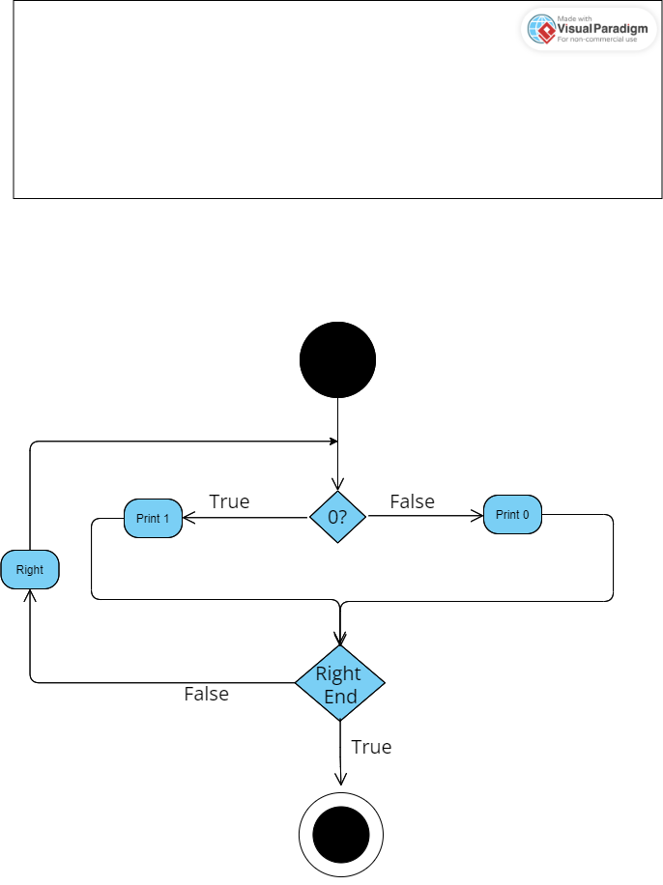

# Program 2: Binary OR Calculation

Description: This Turing Machine computes the logical disjunction (OR) of two binary digits and prints the result on the tape.

START.

IF you are in StateX and scanning 0,

Move RIGHT

Change state to StateA

IF you are in StateX and scanning 1,

Move RIGHT

Change state to StateB

IF you are in StateA and scanning 1,

Move RIGHT

Change state to StateC

IF you are in StateA and scanning 0,

Move RIGHT

Change state to StateD

IF you are in StateB,

Move RIGHT

Change state to StateC

IF you are in StateC, PRINT 1 THEN STOP.

IF you are in StateD, PRINT 0 THEN STOP.  
  
In this program, StateX checks the first input symbol, and depending on whether it's 0 or 1, the machine transitions to either StateA or StateB. StateA and StateB correspond to the second input symbol's value. If the second symbol is 1, the machine moves to StateC and prints 1, indicating a successful OR. If the second symbol is 0, the machine moves to StateD and prints 0, signifying a failed OR.

### ACTIVITY DIAGRAM:

### ActivityD.png

## 5.0 UML Model

Let's visualize the Turing Machine using Unified Modeling Language (UML) diagrams to represent its behavior and structure.

## 5.1 Class Diagram

The Class Diagram provides a graphical representation of the interactions between the Turing Machine and its users, highlighting the various use cases we've explored.

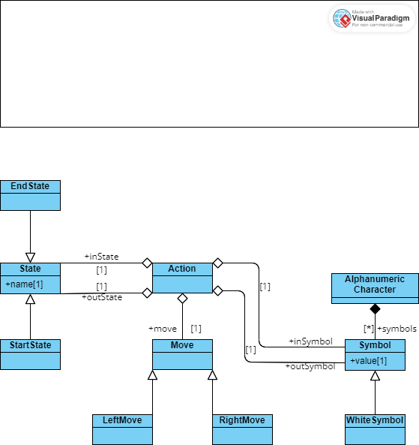

## 5.2 State Diagram

The State Diagram depicts the various states that the Turing Machine can be in and how it transitions between these states during its operation.

The State Diagram provides a visual representation of the Turing Machine's dynamic behavior as it progresses through different states based on the symbols it reads and the transition rules it follows.

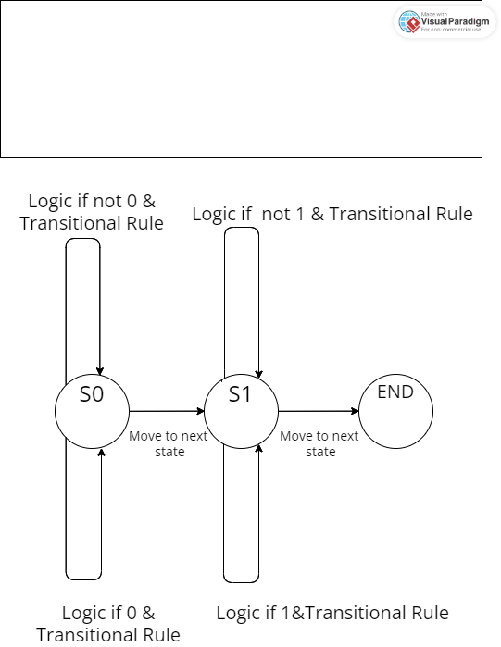

# 6.0 Implementation Details

Now, let's delve into the implementation details of the Turing Machine, including its architecture, input/output mechanisms, and transition function logic.

## 6.1 Turing Machine Architecture

The architecture of a Turing Machine consists of several crucial components that work together to execute computations. These components include:

- Tape: The tape is a fundamental component of the machine's memory. It consists of cells that can hold symbols from the machine's alphabet. The tape extends infinitely in both directions, allowing the machine to access an unbounded amount of data.

- Read/Write Head: The read/write head is responsible for reading symbols from the tape, writing new symbols onto the tape, and moving left or right along the tape. The head's position determines which cell on the tape is currently being processed.

- Transition Function Logic: The heart of the Turing Machine's operation lies in the transition function logic. This logic defines how the machine transitions from one state to another based on the current state and the symbol being read. It specifies the new symbol to write, the direction to move the head, and the new state to enter.

## 6.2 Input/Output Mechanisms

The Turing Machine interacts with input data through its tape and produces output results through its tape as well. The process involves:

- Input: Initially, the input data is loaded onto the tape. The read/write head is positioned over the first cell containing the input symbol to be read. As the machine executes, it reads symbols from the tape, simulating the process of analyzing input data.

- Output: The output of the computation is typically reflected in the final state the machine reaches and the symbols written on the tape. The content of the tape at the end of the computation represents the result of the computational task.

## 6.3 Transition Function Logic

The transition function logic is the essence of the Turing Machine's computational behavior. It defines the machine's response to the combination of its current state and the symbol it reads from the tape. The transition function specifies:

- Current State: The state in which the machine currently resides.

- Read Symbol: The symbol that the machine reads from the tape at its current position.

- Write Symbol: The symbol that the machine writes onto the tape in place of the read symbol.

- Head Movement Direction: The direction in which the read/write head should move after writing the new symbol. This can be "left" or "right."

- Next State: The state to which the machine transitions after completing the specified actions.

The transition function logic encapsulates the rules that govern the machine's behavior. By defining these rules, we determine how the machine processes data, updates its state, and progresses through the computation.

Implementing the transition function logic requires careful consideration of the computational task at hand. It involves creating a set of rules that guide the machine's actions based on the problem's requirements. The elegance and power of the Turing Machine lie in its ability to execute a wide range of computations by manipulating the transition function logic.

In the following sections, we will explore variations of the Turing Machine, its applications in the realm of computer science, its theoretical contributions, and avenues for future enhancements. These discussions will provide a comprehensive understanding of the Turing Machine's significance and its enduring impact on the field of computation.

# 7.0 Turing Machine Variations

While the basic Turing Machine model is a foundational concept, there are several variations and extensions that expand its capabilities and offer deeper insights into computational theory.

## 7.1 Deterministic vs. Non-deterministic Turing Machines

One notable variation is the distinction between deterministic and non-deterministic Turing Machines.

- Deterministic Turing Machine: In a deterministic Turing Machine, the transition rules are uniquely determined for every combination of current state and read symbol. This means that the machine's behavior is entirely predictable and follows a single path for each input.

- Non-deterministic Turing Machine: In a non-deterministic Turing Machine, there can be multiple possible transition rules for a given combination of current state and read symbol. This introduces the concept of branching, where the machine can explore multiple computation paths simultaneously. Non-deterministic Turing Machines are more expressive and can potentially solve certain problems more efficiently.

## 7.2 Universal Turing Machine

Another significant variation is the Universal Turing Machine (UTM). The UTM is a Turing Machine that can simulate the behavior of any other Turing Machine, given the appropriate input. It achieves this by encoding the transition rules and input of the target machine as symbols on its own tape. The UTM's versatility in simulating various machines illustrates the concept of universality in computation – a single machine capable of executing a wide range of computations.

The Universal Turing Machine holds profound implications for the study of computability and complexity theory. It demonstrates the idea that a single computational model can capture the essence of all other computational models, emphasizing the universality of computation itself.

# 8.0 Applications and Significance

The Turing Machine has far-reaching applications and profound significance in the field of computer science.

## 8.1 Theoretical Foundation

The Turing Machine forms the theoretical foundation for the study of computability, complexity theory, and algorithm analysis. It provides a standardized model for exploring what can and cannot be computed algorithmically. The concept of Turing-completeness, which refers to a system's ability to perform any computation that can be described algorithmically, is widely used to evaluate programming languages and computational systems.

## 8.2 Limitations and Computability

The concept of the Turing Machine also introduces the notion of undecidability – the existence of problems for which no algorithmic solution exists. Alan Turing's famous halting problem demonstrates that there is no general algorithm that can determine whether an arbitrary program will eventually halt or run indefinitely. This profound insight highlights the inherent limitations of computation and inspires ongoing research into the boundaries of what can be computed.

## 8.3 Contributions to Computer Science

The Turing Machine's impact on computer science is immeasurable. It laid the groundwork for the development of modern computers, programming languages, and algorithms. The concept of a stored-program computer, where both data and instructions are stored in memory, was influenced by the Turing Machine's tape-based memory.

Moreover, the Turing Machine's influence extends to the development of artificial intelligence, cryptography, theoretical linguistics, and more. It has provided a framework for understanding the nature of computation and the inherent limits of machines.

## 9.0 Future Enhancements

While the Turing Machine is a foundational concept, there are potential enhancements and extensions that can further enrich its capabilities.

## 9.1 Multi-Tape Turing Machines

One enhancement is the concept of Multi-Tape Turing Machines. These machines feature multiple tapes and read/write heads that can interact with each other. Multi-Tape Turing Machines can solve certain problems more efficiently than their single-tape counterparts. They provide a broader range of computational power and can potentially reduce the complexity of algorithms for specific tasks.

## 9.2 Turing Machine Simulators

Turing Machine simulators are software tools that allow researchers, students, and enthusiasts to experiment with and explore the behavior of Turing Machines. These simulators provide interactive environments where users can define transition rules, input data, and observe the machine's execution step by step. Simulators play a crucial role in teaching computational theory and helping researchers experiment with different machine configurations.

# 10.0 Testing Strategy

To ensure the reliability and correctness of Turing Machine implementations, a thorough testing strategy is essential.

## 10.1 Unit Testing

Unit testing involves verifying the behavior of individual components of a Turing Machine. Each component, including the read/write head, tape, and transition function logic, should be tested in isolation to ensure they function correctly.

## 10.2 Functional Testing

Functional testing aims to validate the overall behavior of the Turing Machine by executing various use cases. These tests cover scenarios where the machine processes input data and produces expected output results.

## 10.3 Performance Testing

Performance testing assesses the efficiency and scalability of a Turing Machine implementation. It involves analyzing how the machine performs on large input data and evaluating its resource consumption.

By adopting a comprehensive testing strategy, developers and researchers can ensure that their Turing Machine implementations accurately reflect the intended computational behavior and produce correct results across a range of scenarios.

# 11.0 Conclusion

The Turing Machine, though initially conceived as a theoretical construct, has left an indelible mark on the landscape of computer science. From its foundational role in the study

of computation to its applications in understanding the limits of algorithmic solvability, the Turing Machine continues to shape the way we perceive the boundaries of computational possibilities.

Its variations, such as deterministic and non-deterministic models, and the Universal Turing Machine, further underscore the machine's significance and its ability to model diverse computational processes. By exploring its theoretical underpinnings, practical applications, and potential enhancements, we gain a profound appreciation for the Turing Machine's role in advancing our understanding of computation and its enduring impact on the evolution of technology and thought.